Bendigo Library Spring Program I Craft Project
ABOUT
The theme for spring 2014 at the Goldfields Libraries is connection to the natural environment. A key project as part of the spring program is called Trees, Webs & Hives. A series of activities and events will take place as part of the project including workshops, displays, presentations and craft installations throughout the library. Over spring we aim to explore ideas about the importance of connection inspired by the natural environment and the models of connection; trees, webs and hives.

CRAFT INSTALLATIONS
To coincide with the spring program a series of installations will be on display from September – November exploring the theme of trees, webs and hives. A large crocheted tree (local variety) will be created using yarn and materials. A Crochet web will be suspended from the ceiling above the community lounge. The stairwell in the Bendigo library will become a bee hive with all kinds of crafted bees, flowers and pollinators. The hive will attract more bees and pollinators throughout the months of spring as we will be inviting the community to become involved contribute to growing our hive. A pollinator garden will also be created and attached to the walls in the performance space.

HOW TO BECOME INVOLVED
- Join the community crafting table in the Red Well Café at the Bendigo Library Friday mornings 10am-12pm from July-November
- Make crafted bees and pollinators at home or with a group you are involved in. Pick up patterns from the beehive in the Bendigo Library or download them from our website. Once complete bring your crafty creations into the Bendigo Library and we will attach them to the growing bee hive and garden throughout spring.

IMPORTANT DATES
Trees Webs & Hives Craft Installation Bendigo Library, on display 1 September- 30 November 2014

Trees Webs & Hives Community Crafting Table Red Well Café, Bendigo Library
Friday mornings 10am-12pm

The Bee hive Will be buzzing from Sept-Nov crafters and groups are invited to bring their spring creations into the library and attach to our growing hive.

For further information
Please contact project coordinator
Helen Coughlan
e. hellybellys@hotmail.com
m. 0466 487 827

Crochet pattern
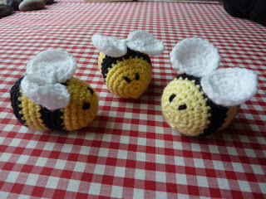

Yarn – Double knitting oddments in yellow, black and white
Hook – 3 mm or 3.5 mm (whichever suits).
Notions – toy stuffing.
Finished size – approximately 7 cm in length

Body
With yellow make 2 chain.
1st round: 6 dc into 2nd chain from hook. Join with a slip st into 1st dc. 2nd round: 1 ch, 2 dc into same stitch as chain, [2 dc into next dc] 5 times. Sl st into 1st dc. (12 dc) 3rd round: 1 ch, 1 dc into each stitch to end, sl st into first dc. 4th round: 1 ch, 2 dc into same stitch as chain, 1 dc into next dc, [2 dc into next dc, 1 dc into next dc] 5 times. Sl st into 1st dc. (18 dc) 5th round: 1 ch, 2 dc into same stitch as chain, 1 dc into next 2 dc, [2 dc into next dc, 1 dc into next 2 dc] 5 times. Sl st into 1st dc. (24 dc) 6th round: 1 ch, 1 dc into each stitch to end, sl st into first dc. Change to black. 7th round: 1 ch, 2 dc into same stitch as chain, 1 dc into next 3 dc, [2 dc into next dc, 1 dc into next 3 dc] 5 times. Sl st into 1st dc. (30 dc) 8th round: 1 ch, 1 dc into each stitch to end, sl st into first dc. 9th round: 1 ch, 1 dc into each stitch to end, sl st into first dc. Change to yellow. 10th – 12th rounds: 1 ch, 1 dc into each stitch to end, sl st into first dc. Change to black.
13th round: 1 ch, 1 dc into each stitch to end, sl st into first dc. 14th round: 1 ch, 2 dctog, 1 dc into next 3 dc, [2 dctog, 1 dc into next 3 dc] 5 times. Sl st into 1st dc. (24 dc)
15th round: 1 ch, 2 dctog, 1 dc into next 2 dc, [2 dctog, 1 dc into next 2 dc] 5 times. Sl st into 1st dc. (18 dc). Change to yellow. Insert stuffing at this point. 16th round: 1 ch, 2 dctog, 1 dc into next 1 dc, [2 dctog, 1 dc into next 1 dc] 5 times. Sl st into 1st dc. (12 dc) 17th round: 1 ch, [2 dctog,] 6times. Sl st into 1st dc. (6 dc). Fasten off and close opening.

Wings (make 2)
With white make 2 chain.
1st round: 6 dc into 2nd chain from hook. Join with a slip st into 1st dc. 2nd round: 1 ch, 2 dc into same stitch as chain, [2 dc into next dc] 5 times. Sl st into 1st dc. (12 dc) 3rd round: 1 ch, 2 dc into same stitch as chain, 1 dc into next stitch, [2 tr into next stitch, 1 tr into next stitch] 4 times, 2 dc into next stitch, 1 dc into last stitch, sl st into first dc. (18 stitches) Fasten off.

Join wings together at dc side of circles and attach to top of body

Felt Bumble Bee
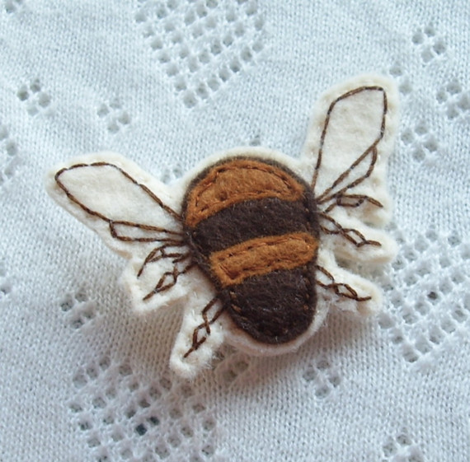
Make this little Bumble bee using three shades of felt stitched with brown thread.
Knitting pattern for buzzy bees
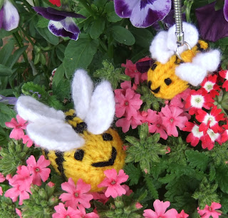
Cast on 5 stitches in Yellow
R1: Increase to 10 stitches by knitting into front and back of each stitch.
R2: purl
R3: knit
R4: purl

Alternate black and yellow to make black and yellow stripes, one row each. Finish with black at R11 below.

R11: p2 together in black, cut both yarns, draw through black and fasten off. Use yellow end to sew seam, stuffing as you go. Embroider eyes and smile.

Wings (make 4 in white)
Cast on 10 stitches, cut yarn leaving a long end and pull through to form a circular wing (you may need to sew an additional stitch or two to form the circle) Stitch in place. You can overlap front/back slightly for effect.

